**Title: Intel products sentiment analysis using online reviews**

**Objective**

* Develop a sentiment analysis system to automatically classify online reviews of Intel products as positive, negative, or neutral.
* Provide actionable insights to Intel based on the sentiment analysis results.
* Implement a machine learning model trained on a large dataset of Intel product reviews to accurately predict sentiment.
* Utilize natural language processing (NLP) techniques to preprocess text data and extract relevant features for sentiment classification.
* Sentiment classification (positive, negative, neutral).
* Topic extraction to identify common themes in reviews.
* Sentiment trend analysis over time.
* Comparison of sentiment across different Intel product categories.
* Integration with Intel’s existing analytics and customer feedback systems.

• **Data Collection:** Gather online reviews from various platforms (e.g., Amazon).

• **Data Preprocessing:** Clean and tokenize text data, remove stopwords, and perform stemming or lemmatization.

• **Feature Extraction:** Use NLP techniques to extract features such as n-grams, sentiment scores, and topic modeling.

• **Model Training:** Develop and train a sentiment classification model using supervised learning algorithms (e.g., SVM).

• **Model Evaluation:** Assess the performance of the model using metrics like accuracy, precision, recall, and F1-score.

• **Deployment:** Deploy the trained model to classify new incoming reviews in real-time

**Architecture Diagram**

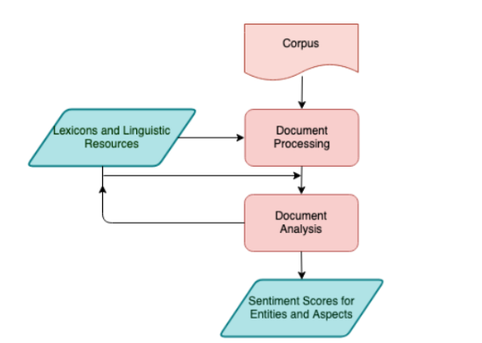

* Python for programming language.
* Libraries/frameworks: NLTK, Scikit-learn, TensorFlow/Keras (for deep learning models).
* Data storage: MongoDB/MySQL for storing processed data and model outputs.
* Deployment: Flask/Django for API development to integrate with Intel’s systems.
* The sentiment analysis system provides Intel with valuable insights into customer perceptions of their products.
* By leveraging NLP and machine learning techniques, Intel can improve decision-making processes and enhance customer satisfaction.
* Future enhancements could include sentiment analysis on social media platforms and sentiment-driven product improvements.